**Testnet Authorization Setup - RSA Token**

Please try this procedure.

First navigate to the UPSers.com Applications screen

[Applications (ups.com)](https://ep.ups.com/upsers/myportal/portalhome/applications)

From here:

1. Select the **Password Reset / ID Services** option.

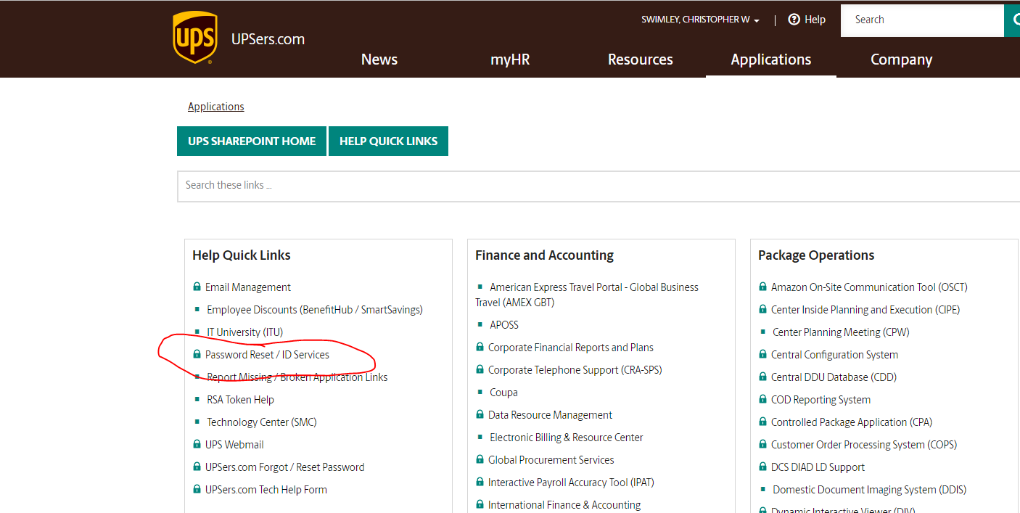

1. Select **Password Reset** menu option.

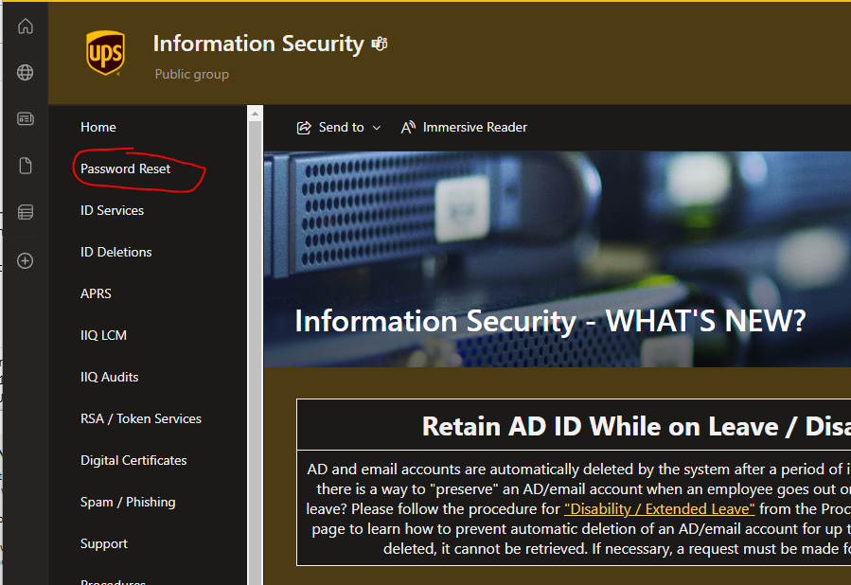

1. Select the **Testnet AD** option.

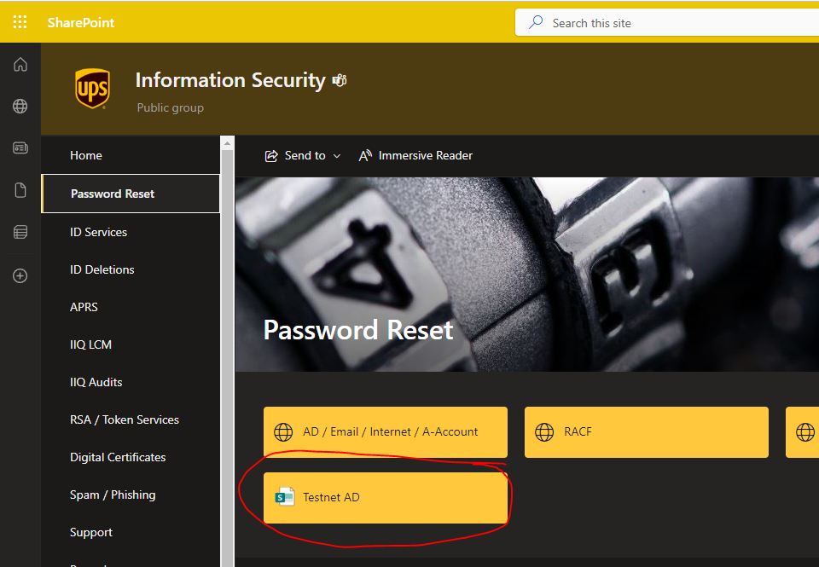

1. Click the **Testnet AD ID Password Reset** option.

This will allow you to get a “new” password assigned for your Testnet ID (TUS\JYV4QWG)

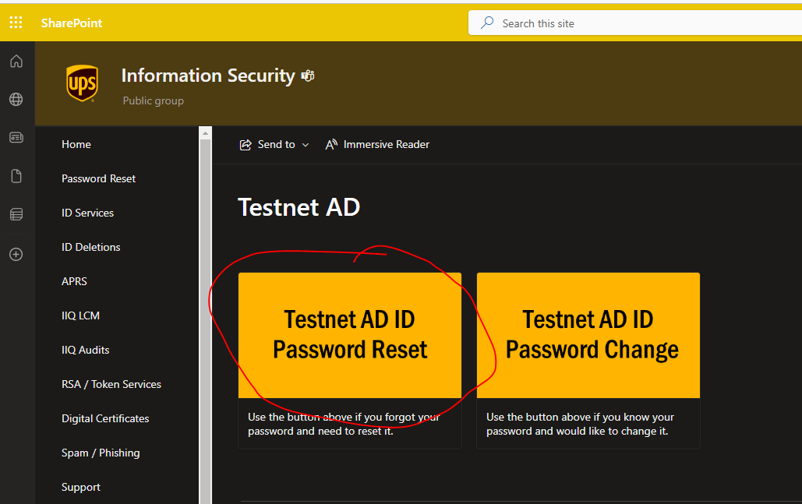

1. Enter your ADID (JYV4QWG)

The 3 action buttons will become active.

Select the **Reset** **Password** button first.

This will generate a random password and will be sent to your email.

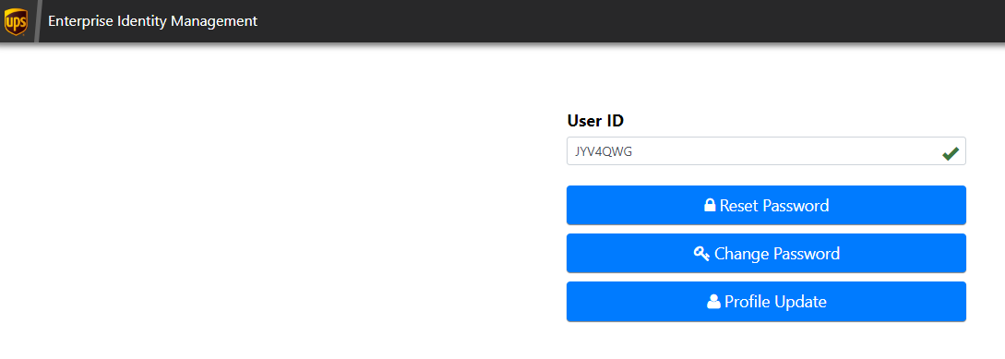

1. Once you have the new password, return to this screen and select **Testnet AD ID Password Change** button

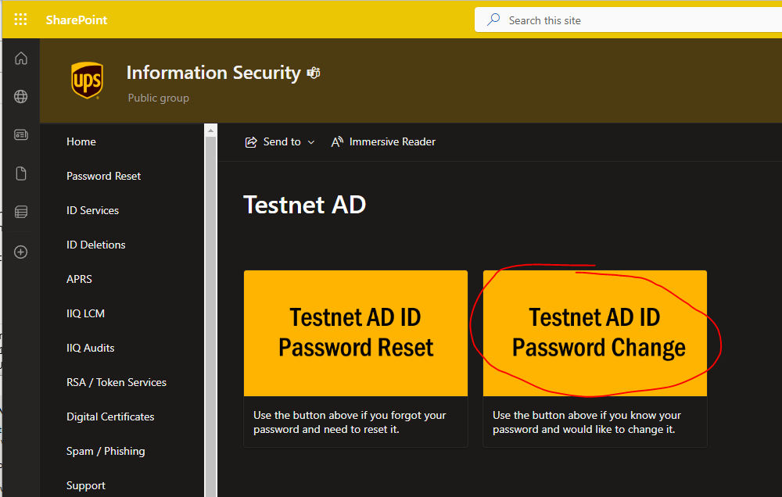

1. Enter your ADID ( JYV4QWG )

The 3 action buttons will become active.

Select the **Change Password** button.

This will allow you to create your own password for testnet authentication.



1. Once you have reset your password to something you can remember, you will need to Sync the ID for your RSA Token for authentication.

Follow the information in the attached email.

Hopefully this solves all your Testnet connection issues.